Porting Computer Programming Lab for Web Compliance
Project Report

Apurv, Girraj, Parvesh ( Project Interns )
Center For Converging Technologies,
University Of Rajasthan ( Jaipur )

Abstract

Web 2.0 Compliance :
The technologies used in Web 2.0 development include Ajax and JavaScript frameworks such as YUI Library, DojoToolkit, MooTools, jQuery, Ext JSand Prototype JavaScript Framework. Ajax programming uses JavaScript to upload and download new data from the Web server without undergoing a full page reload.
To allow users to continue to interact with the page, communications such as data requests going to the server are separated from data coming back to the page (asynchronously). Otherwise, the user would have to routinely wait for the data to come back before they can do anything else on that page, just as a user has to wait for a page to complete the reload. This also increases overall performance of the site, as the sending of requests can complete quicker independent of blocking and queueing required to send data back to the client.
The data fetched by an Ajax request is typically formatted in XML or JSON (JavaScript Object Notation) format, two widely used structured data formats. Since both of these formats are natively understood by JavaScript, a programmer can easily use them to transmit structured data in their Web application. When this data is received via Ajax, the JavaScript program then uses the Document Object Model (DOM) to dynamically update the Web page based on the new data, allowing for a rapid and interactive user experience.
The purpose of this project work is to make web 2.0 compliant labs. The simulations for the experiments of most of the labs are originally written in non web 2.0 compliant technologies such as flash.

Introduction
Tablets only support apps that are web 2.0 compliant. The simulations for computer programming labs were originally written in flash. We wanted this lab to run on tablets as well. Hence we decided to bring the Computer Programming Lab to JavaScript.
Why Computer Programming Lab ? :
Initially, we wanted to port a very popular lab to JavaScript. As per our analytics, Computer Programming Lab is a very popular lab.
- The original simulations were written in flash.
- Total number of experiments in the lab are 10.
- Source codes were available only for 5 of them.

Technologies Used :
- HTML5 ( canvas )
- CSS
- JavaScript

Project Design
We designed a new User Interface for every simulation. This UI is almost common to every simulation in the lab. We can divide the UI basically into 3 parts:
- Initialization Section :
In this section, users initialize certain variables, choose different kind of operations to perform. These inputs are used for the further calculations in the experiment. This section can have the following components :
- Input Boxes
- Buttons
- Lists
- Radio Buttons etc.

- Step Execution Section :
In this section, users see the step by step execution of the code. This section basically behaves as an interpreter.

- Output Section :
In this section, the output of the executed code is displayed. This section is basically divided into two parts :
- Visual output of the code, images etc.
- Local variables used in the program.

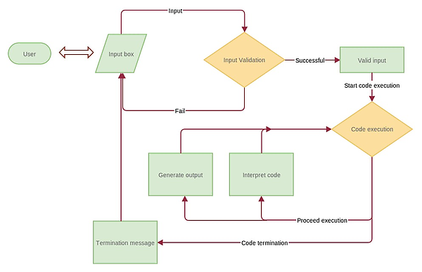
Fig :- Generic DFD of simulations
Implementation of the project design
Implementation of the project desing depends upon the behaviour of the simulations. Model View Controller (MVC) architecture can easily be applied on the simulations of this lab because,
- In these simulations there is a lot of content to be displayed on the web page. ( View )
- Some data needs to be processed logically, to generate the output of the program. ( Model )
- Event Handlers for the user to interact with the simulations. ( Controller )
The Model part for these simulations is very simple. Most of the code goes to the View Part. Every simulation has 3 – 4 controllers.
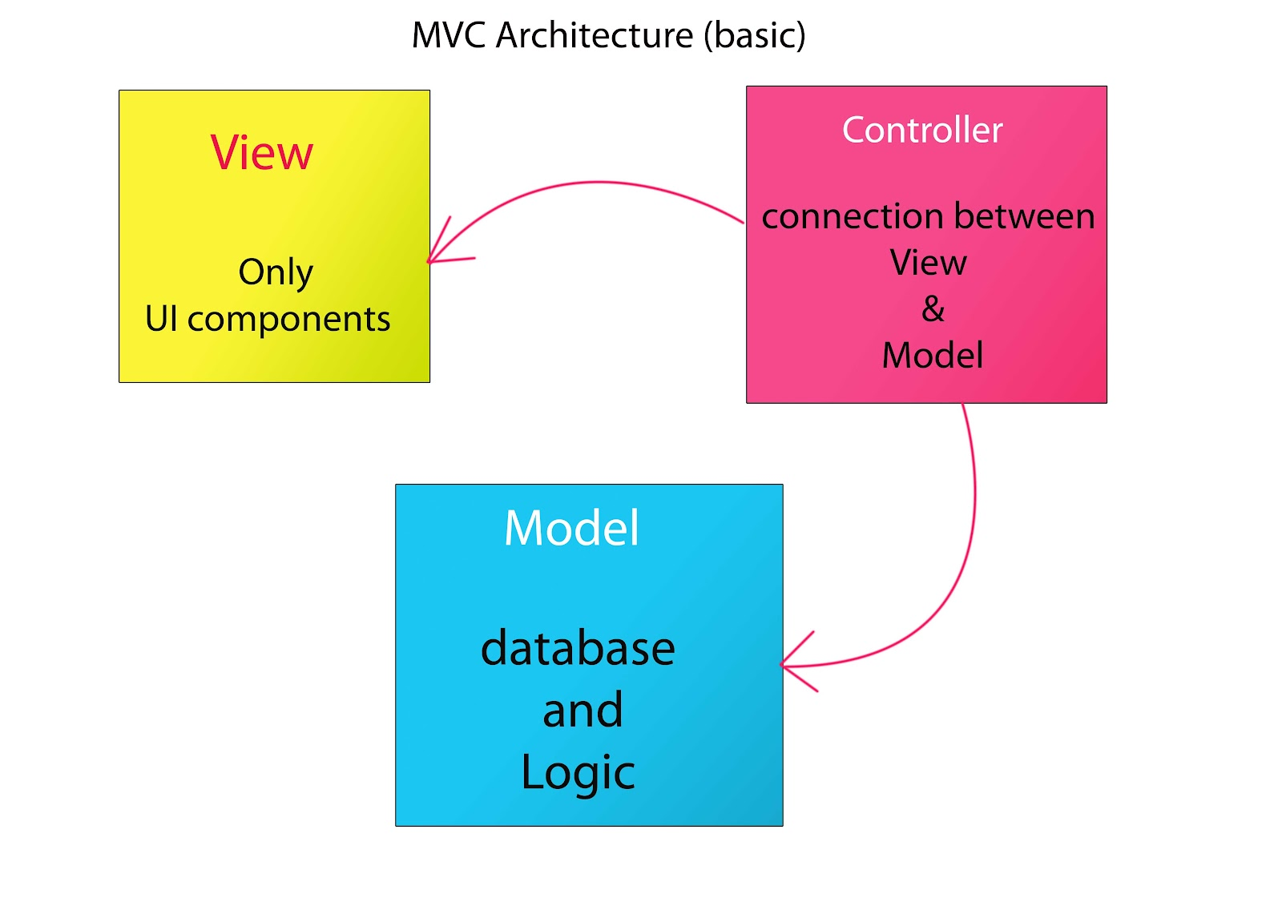
Learning :
- Design Patterns
MVC architecture

- Technologies
JSON
Git
Media Queries

- Coding Practices
Structural Code Refactoring and Code Reusability

Technical difficulties :
- Non responsive behaviour of canvas
<canvas> tag in HTML is hard coded to pixels. Hence, It may or may not behave responsively. Possible solutions for this problems are,
- Use two different sized canvas, one for the normal desktop/laptop size, other for the tablet.
- Set the size of the canvas such as it works for desktop/laptop and tablets as well.

- Non responsive behaviour of images
Images are responsive to a certain extent but they too don’t get perfectly resized. This problem can be solved by using multiple images. Here we’ve used 2 images in the simulation of 1-D array experiment. This can be done via two methods,
- Set multiple images from JavaScript.
- Use media queries.

- Changing the User Interface for some simulations
For some simulations, the user interaction was very poor or difficult for user to operate i.e. local variables were not in front of the user every time, lots of pop ups, alert messages etc.
Changing such poor UI is a very crucial task to perform. Optimizing the user experience needs a lot of psychological expertise as well.

Conclusion
In this report we have discussed about the web 2.0 compliant apps, project design, implementation of the project design, technologies used, learning involved, the technical difficulties etc. while developing Computer Programming Lab’s responsive design implemented through HTML5.
As per our experience a team is required to accomplish this task. Atleast one of the team member should have the experience with CSS and UI design. Total effort per simulation per engineer is shown below in the table.

S. No. | Task Name | Duration
1. | Design and Styling ( HTML and CSS ) | 1 – 1.5 weeks
2. | Implementation ( JavaScript ) | 4 – 4.5 weeks
 | Total | 5 – 6 weeks

